1.
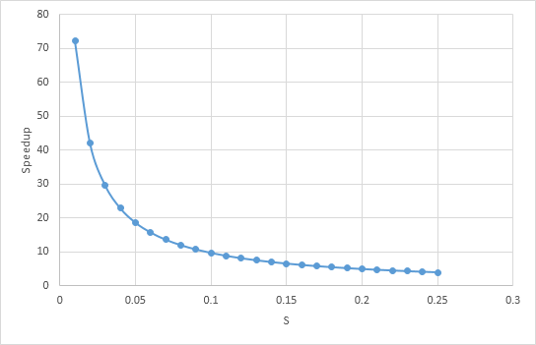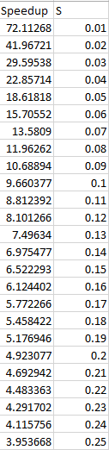
2.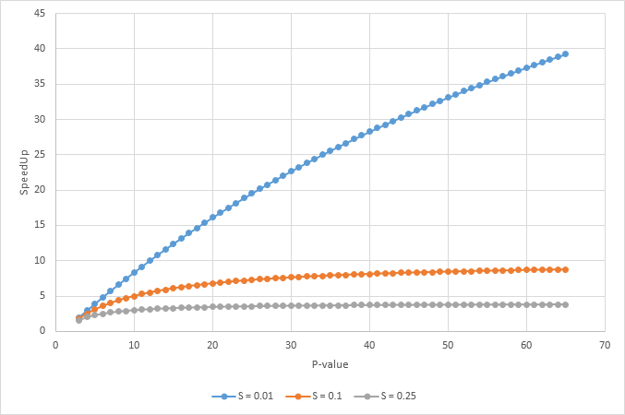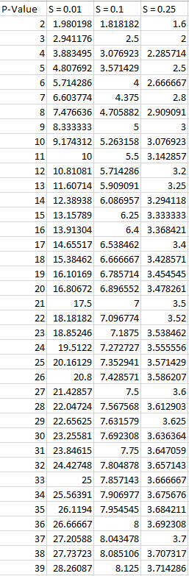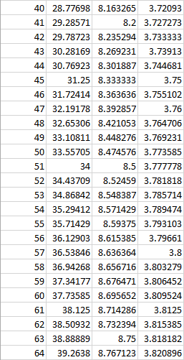
3.1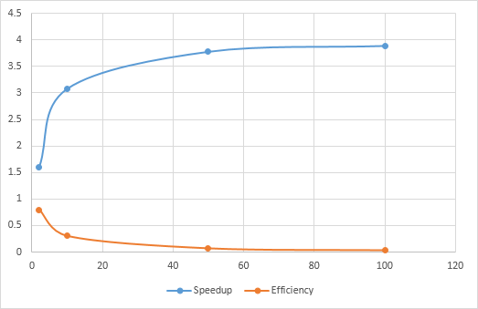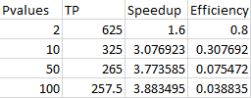
3.2) As number of processors increase, the higher the Speedup so it should be P = 100 since it’s at its highest speedup. The highest speedup should be the minimum time. The theoretical limit is 250 but increasing the number of processors will never reach it.
3.3) As overall Speedup Increases, Efficiency decreases.

